

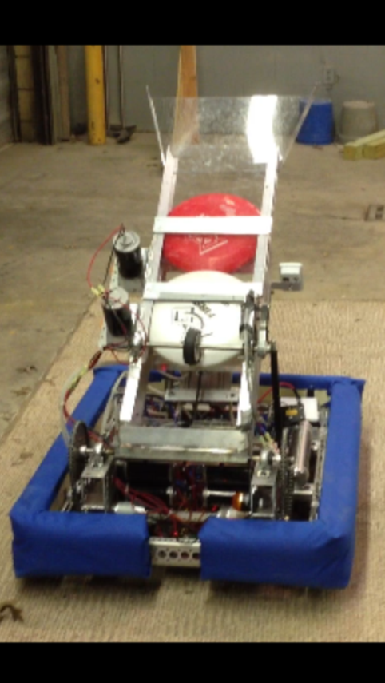

www.parts3492.webs.com

PROUDLY PRESENTS…

~ DJ ~

**CAPABILITES:**

* **Is capable of both defensive and offensive**

**strategies**

* **Can accurately shoot Frisbees into 3-point goal**

**DRIVER CONTROL /FEEDBACK:**

* **Arcade drive with gamepad**
* **Toggle-switch ‘Gunner Box’ for shooter**
* **Camera feed available**
* **Has two-speed gearbox that provides fast high**

**-speed travel and precise, deliberate-low speed**

**movements**

* **Capable of adjustable trajectory to compensate**

**for a goal of any point value**

**CHASSIS:**

* 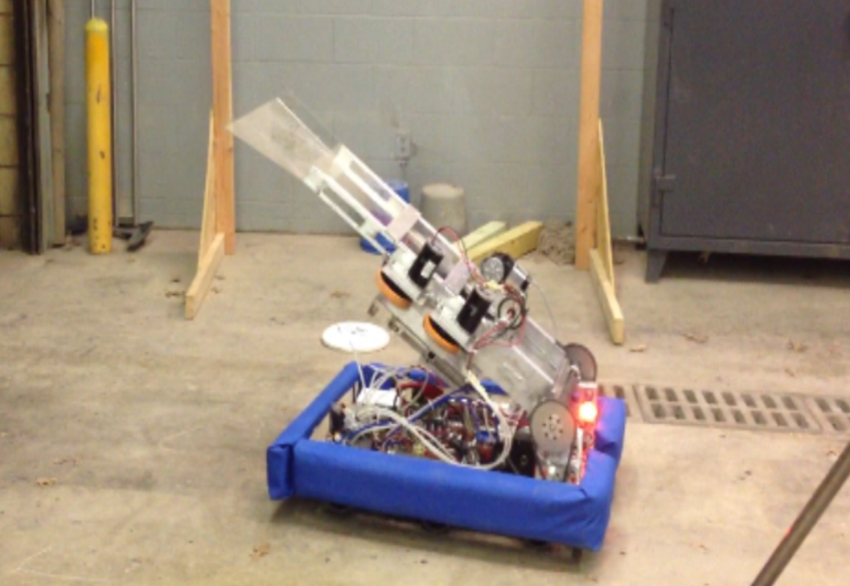**Possesses 6-wheel drive with 4’’ Vexpro Carpet**

**Traction Wheels**

* **2-speed transmission**
* **Chain drive**

**AUTONOMOUS:**

* **Shoots three Frisbees into three-point goal**

**CLIMBING:**

* **Makes effortless ten-point climb**

**SHOOTER:**

* **Robust linear design**
* **Two 6” Banebots wheels powered by CIM motors**
* **True-spin overdrive gearboxes**